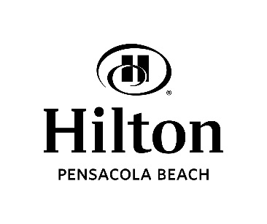
MAKING RESERVATIONS WITHIN A GROUP BLOCK ONLINE

Conference: ALSHP Summer Clinical Meeting 2023

Reservation deadline: May 31, 2023

Property Location:
Hilton Pensacola Beach
12 Via de Luna Drive
Pensacola Beach FL 32561
1-866-916-2999 - Ask for “Reservations”
Direct - 850-916-2999

Online Reservations:
Website: www.hiltonpensacolabeach.com

- Enter check-in & check-out dates on screen and click “Go” button.
- “Dates” These dates must be within the time period the rooms are blocked for your group. Reservations can be made from June 24, 2023 and departure June 27, 2023. If you try to book dates outside of this range, you will most likely get a message that there are insufficient rooms available. In that case, make your reservation directly with the hotel by calling the number above.
- Choose “Room Type Preferences.” The rooms that appear are the rooms that are available to our group.
- “Special Accounts” Enter your Group/Convention code of ALSHP2.
- “Continue” This should pull up the rate that has been set up for your group.
- A credit card is required to complete your reservation.

*Please make your reservations as soon as possible. The rooming block will close before the deadline date if the block has sold out. Reservations that are made after the deadline date are subject to hotel rates and availability.

Amenities: Directly on the Gulf of Mexico, this property offers a restaurant, sushi bar (open Tues-Sat), outdoor bar (seasonal), fitness room, indoor pool, outdoor heated pool, outdoor Jacuzzi, cabanas, complimentary business center and one of the best rated beaches in the U.S. All guest rooms feature the following: microwave, refrigerator, coffeemaker, hairdryer, iron/ironing board, complimentary WiFi.

Our Hilton beachfront hotel offers all the amenities you desire to create a fun and memorable beach vacation or business trip. From our exceptional views to our friendly staff, on-site dining and endless area attractions, you’ll find everything you need is right within your reach.

Looking for fun things to do during your stay in Pensacola? We’ve got you covered! We’ve partnered with our favorite local activity operators to give you access to all the best activities in one place. From cruises to rentals, there’s something for everyone to enjoy! Browse https://www.visitpensacola.com/plan-your-trip/visitors-center/ and book your activities.

