Annual BAHPS CE Program
FRANK-N-STEIN
Located at The Oyster City Brewing Co.
600 Government Street, Mobile, Al. 36602
October 28th, 2022 – Presentation begins 6:00 PM
Presenter: Thomas Cobb Pharm. D. Member of Alabama Board of Pharmacy
Pharmacy Law: ACPE Accredited 1 hour Live CE for Technicians and Pharmacists
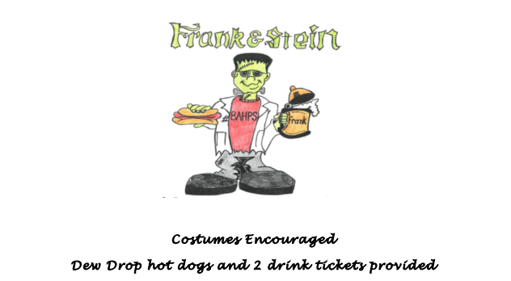
RSVP by October 24th, 2022 – bayareapharm@gmail.com
