

**Pharmacy Leaders Forum**

Tuesday, September 27, 2022

2 PM

**Moderator:** Leborah Lee

**Attendees:** Leborah Lee, Dan Gillis, Julie Lasseigne, Brenda Denson, Michael McDaniel, Jacey Cox, Jim Easter, Roland Naseman, Shelly Cunningham, Trey Dailey

1. FDA updated guidance to USP General Chapter <1178> (submitted by Jim Easter at Citizens Baptist Medical Center):
   * Latest guidance by the FDA, see link below: https://www.fda.gov/media/70985/download it references USP General Chapter <1178> Good Repackaging Practices recommends which states the expiration date “not exceed (1) 6 months from the date of repackaging; or (2) the manufacturer’s expiration date; or (3) 25% of the time between the date of repackaging and the expiration date shown on the manufacturer’s bulk article container of the drug being repackaged, whichever is earlier.”7
   * Jim stated that there was an ISMP alert and FDA letter regarding the expiration dating of repackaged medications, but ASHP guidelines did not recommend the 6-month expiration.
   * In discussion, Julie commented that it appears state licensed pharmacies are excluded.
   * Additionally, Jim commented that there is a list of medications that should not be repackaged. Certain specialty medications are only good for 30 days once it is opened.
   * Rivaroxaban only good for 4 hours if split.
2. Open Forum

Topics: JC, ISMP call, Drug shortages

* Joint Commission:
  + Julie commented on Children’s having the JC survey the week of Sept 20th. They reviewed staff competencies, 797 competency and remediation documentation. They used blue lights to look for something (it was unclear what exactly), reviewed environmental control and cleaning records, temperature monitor calibration. For the Primex temperature monitoring, there is no calibration, it is just a replacement of the probes at a certain time. The silent knight pill crusher cleaning records were reviewed in other areas, but not pharmacy. Julie commented that the JC surveyor in the OR was looking for propofol syringes in the sharps containers. The JC surveyors were reviewing contracts for 503B pharmacies used to see if quality measures/expectations were clearly defined. She noted that most of these 503B’s do not have boiler plate contracts, and you may need to design the quality measures and time frames such as quarterly updates, etc in your contracts with them. Important that staff know kill times for different colored disinfectant wipes.
  + Leborah discussed the JC survey at Jackson recently. They were cited for the silent knight pill crushers and now they use a device where plastic sleeves are used. (to note: Children’s uses sleeves for the silent knight pill crusher). Leborah also discussed how JC looked at prn/same indication.

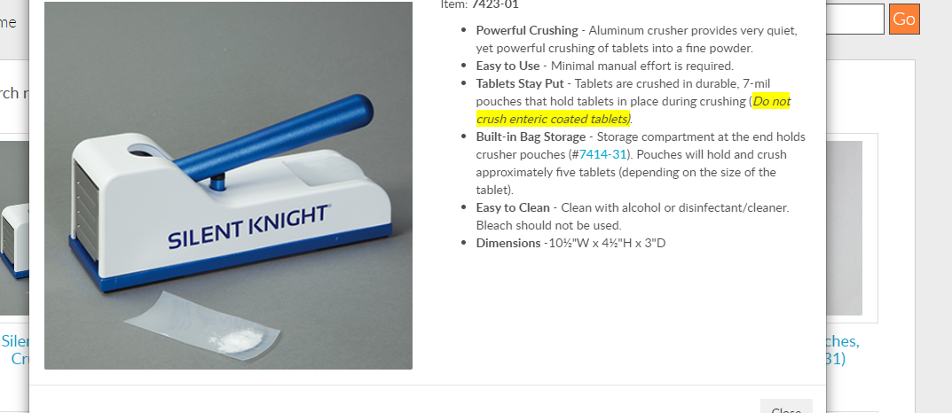

* + Roland stated that Mobile Infirmary is in their JC window and he would appreciate any JC notes/pearls if anyone would like to send to him.
* ISMP call (Jim Easter):
  + During an ISMP call it was discussed that approximately 120 patients received old COVID boosters instead of the new bivalent COVID boosters at a facility.
  + Expiration dating on the new bivalent COVID vaccines can be found by scanning the 2D bar code on the product.
* Drug shortages:
  + Trey asked what others were doing or if they were having issues obtaining Pitocin and Octreotide.
  + Dan mentioned that the plant that manufactures many MVI’s for TPN’s was damaged by the hurricane that hit Puerto Rico.

1. Additional Information:
   * Annual Meeting on November 3rd and 4th
     + Address:
       - Montgomery Marriott Prattville Hotel & Conference Center at Capitol Hill
       - 2500 Legends Circle, Prattville, Alabama 36066
     + There will be a Leadership Track on November 3rd and a Reverse Expo with free registration if you attend the Reverse Expo.
   * Next Meeting:
     + Alabama Drug Diversion Prevention Small Group