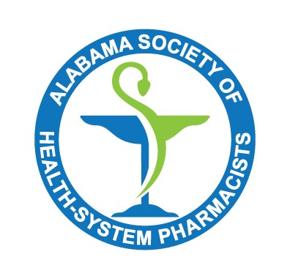
Pharmacy Leaders Forum
Tuesday, October 25, 2022
2 PM

Moderator: Leborah Lee

Attendees: Dan Gillis, Leborah Lee, Marshall Robbins, Brenda Denson, Anuar Sahori, Lakeyra Palmer, Julie Lasseigne, Randy Hooks, Tommy Cobb, Jacey Cox, Sarah Hancock, Charlie Darling, Trey Dailey, Roland Naseman and Jessica Walton
- Alabama Drug Diversion Prevention Small Group (presented by Lakeyra Palmer from University of Alabama Birmingham Hospital)
  - Lakeyra Palmer from UAB Highlands reviewed their audit from 4 DEA agents.
    - The time frame reviewed was January 2021 to March 2022. The agents were onsite for one month, and they audited 8 controlled substances of the DEA’s choosing. When the DEA agents arrived without warning and handed the pharmacy a notify of inspection. It helps to have someone with the DEA agent with them all day to answer questions; however, before any information was given to the agents (which has to be in a PDF format), the UAB legal department reviewed such information. The officers asked about security (cameras and access), and they were interested in the OR areas.
    - Following the visit, there were no administrative or civil actions or citations for UAB Highlands. Part of this was because of their multidisciplinary team with nursing, pharmacy, and HR. The institution has now implemented mock surveys, and their practices were considered best practices at the end of the visit.
  - The Alabama Drug Diversion Prevention Small Group was created by Lakeyra after the DEA visit as a knowledge sharing committee.
    - This small group brings together legal agencies and other hospital pharmacists to look at best practices for controlled substances. This group is collaborating with ALSHP, and it has not been decided which Director this group will fall under.
    - The small group has met once and is looking meet again in November (date TBD).
      - The next meeting will review Best Practice Guidelines and what the group would like to work on in the future. They are looking to review pros and cons of different vendors for drug diversion for hospital systems.
- ASHP and SIDP Survey (submitted by Dan Gillis, Executive Director of AlSHP):
  - ASHP is soliciting comments on the Draft American Society of Health-System Pharmacists (ASHP) and the Society of Infectious Diseases Pharmacists (SIDP) Joint Statement on the Pharmacist’s Role in Leading Antimicrobial Stewardship Efforts. Because of your interest and expertise in the subject, ASHP is inviting you to review the draft. Please submit your comments using the survey tool. The document is available via the URL below: https://www.ashp.org/pharmacy-practice/policy-positions-and-guidelines/draft-guidance-documents
- Open Forum
  - Tommy Cobb from ALBOP:
    - Reminder: changes to the Institutional Rule go into effect in November. See https://albop.com/ for more information.
- Additional Information:
  - Annual Meeting on November 3rd and 4th
    - Address:
      - Montgomery Marriott Prattville Hotel & Conference Center at Capitol Hill
      - 2500 Legends Circle, Prattville, Alabama 36066
    - There will be a Leadership Track on November 3rd and a Reverse Expo with free registration if you attend the Reverse Expo.

