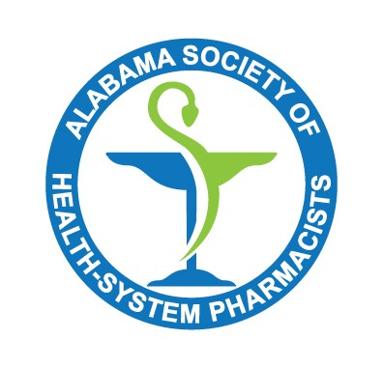
Pharmacy Leaders Forum
Tuesday, August 23, 2022
2 PM

Moderator: Dan Gillis

Attendees: Michael McDaniel, Jacey Cox, Dan Gillis, Marshall Robbins, Mary McKnight, Jennifer Anderson-Fung, Joshua Settle, Roland Naseman, Julie Lasseigne

- Protect 340B (submitted by Thomas Cobb, Jackson Hospital):
  - https://www.protect340bpatients.org/?utm_campaign=GRD-Newslink-1-00-1135-52000&utm_medium=email&_hsmi=221161712&_hsenc=p2ANqtz-9PCORtGapUqKFNx1MtCc60VqKeAR5FvArz5EAvKQ7vxgFu17z7yLOUULfySbi5XNQdKymed7HLg759QWku3t_hzyzgeA&utm_content=221161712&utm_source=hs_email
  - Tommy Cobb wanted to raise awareness of this website that is also endorsed by ASHP.
  - Huntsville Hospital has sent this link out on social media.
- Open Forum
  - Controlled Substance Inventory Compliance – Dan Gillis
    - UAB has started a controlled substance compliance discussion group led by Lakeyra Palmer after a recent DEA audit.
    - UAB, Children’s of Alabama, and Baptist South participated in the first meeting.
    - Would the ALSHP Leaders Forum like to invite Lakeyra Palmer to come and discuss – yes
    - Dan Gillis to reach out to Lakeyra Palmer with UAB.
  - TPA Fee negotiations – Michael McDaniel
    - Verity is Huntsville Hospital’s TPA.
    - They currently do not charge a fee on non-profitable 340B contract pharmacies but have announced that they will start charging a fee in the future.
    - The TPA fees can also make a difference in whether a contract pharmacy is profitable (a $1600 fee might eliminate all profit where a $800 fee might leave a pharmacy profitable).
    - Has anyone in the group had success with negotiating smaller monthly fees with their TPA?
      - Would seem to make sense for both parties because the hospital is likely to drop unprofitable contract pharmacies if they must pay a larger fee to the TPA.
      - No one voiced experience with this type of negotiation.
      - Many expressed that they did not have that many contract pharmacies.
      - Huntsville plans to negotiate with Verity.
  - ALBOP items – Dan Gillis
    - Collaborative Practice
      - ALBOP has not received many protocols for Collaborative Practice even though there was a lot of interest in getting Collaborative Practice in the state.
      - Protocols approved by Med Exec in Institutional Pharmacies are exempt from this rule.
    - Tech Ratio
      - The technician ratio change from 3:1 to 4:1 is out for public comment.
    - Institutional Rule change
      - The change to Institutional Rule to allow for dispensing of inhalers to go home is out for public comment.
    - Paxlovid Partial Pack Dispensing
      - ALBOP also discussed hospitals dispensing the rest of a Paxlovid pack to go home with patients.
      - Some retail pharmacies have already been splitting Paxlovid packs in these situations.
  - ALSHP Elections and Awards– Dan Gillis
    - ALSHP elections are coming up.
      - Director of Professional Affairs
      - Director of Educational Affairs
      - President Elect
    - ALSHP Awards nominations are open
    - ALSHP is accepting applications for Fellow of ALSHP.
  - ALSHP Job Board – Dan Gillis
    - ALSHP is launching a job board
    - Jobs will be posted on the website, in the newsletter, and emailed out to membership
    - Postings are free to members, but there is a fee for non-members
    - You will not need to login to see the job postings on ALSHP’s website, so non-members can also view the postings.

